Western Ghats Arduino Manual

This water quality probe is designed to measure four water quality parameters (recorded every 5 minutes in real-time): conductivity (mS/cm), dissolved oxygen (mg/l), temperature (°C), and pressure (m). Pressure is equivalent to meters, 1m = 1mb.

The component parts of the Arduino: Atlas scientific dissolved oxygen probe (5V) and shield; thermistor; pressure sensor; homemade conductivity probe with anodes made of copper coated copper wire; Arduino Pro Mini 3.3V; SD card and SD card holder; ds3234 alarm clock; 6 x AA batteries, and breadboard based voltage regulator and a transistor.

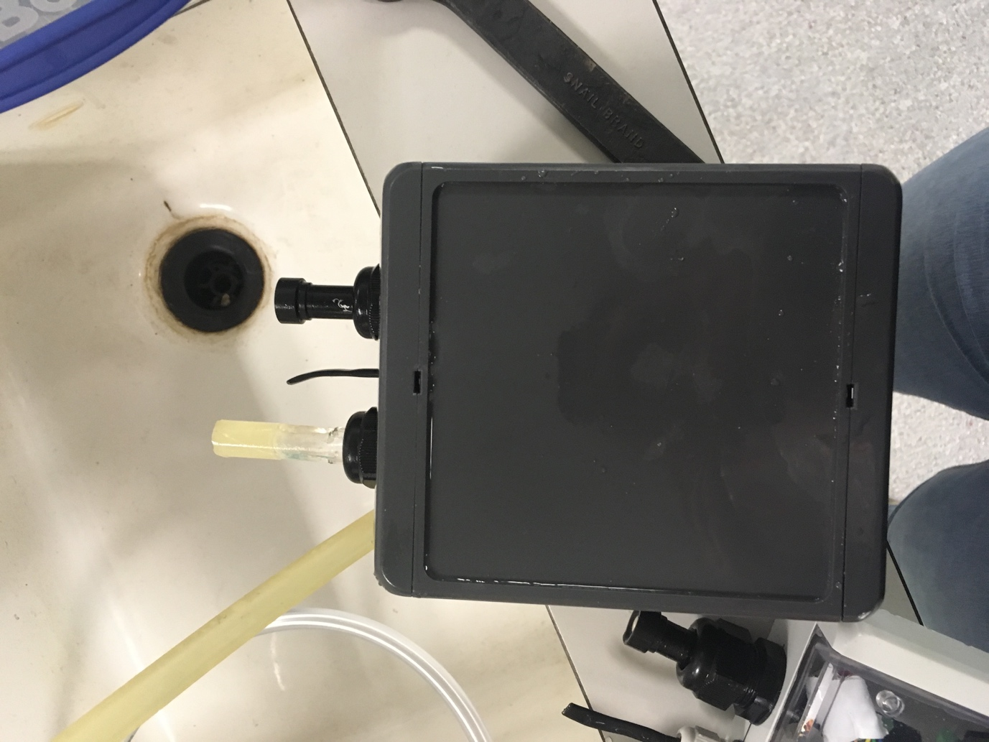

Handmade conductivity probe. Silver coated copper wire protected by plastic piping with holes to allow water pass through.

Temperature sensor. Thermistor is heatshrink wrapped.

Atlas Scientific Dissolved Oxygen Probe

Waterproof glands to surround probes and prevent water intrusion.

IP68 Waterproof casing sealed with grease.

Pressure Sensor underneath the probe coming out of the interior of the box. The actual pressure sensor is approximately 1.5cm in diameter and could not penetrate the walls of the box.

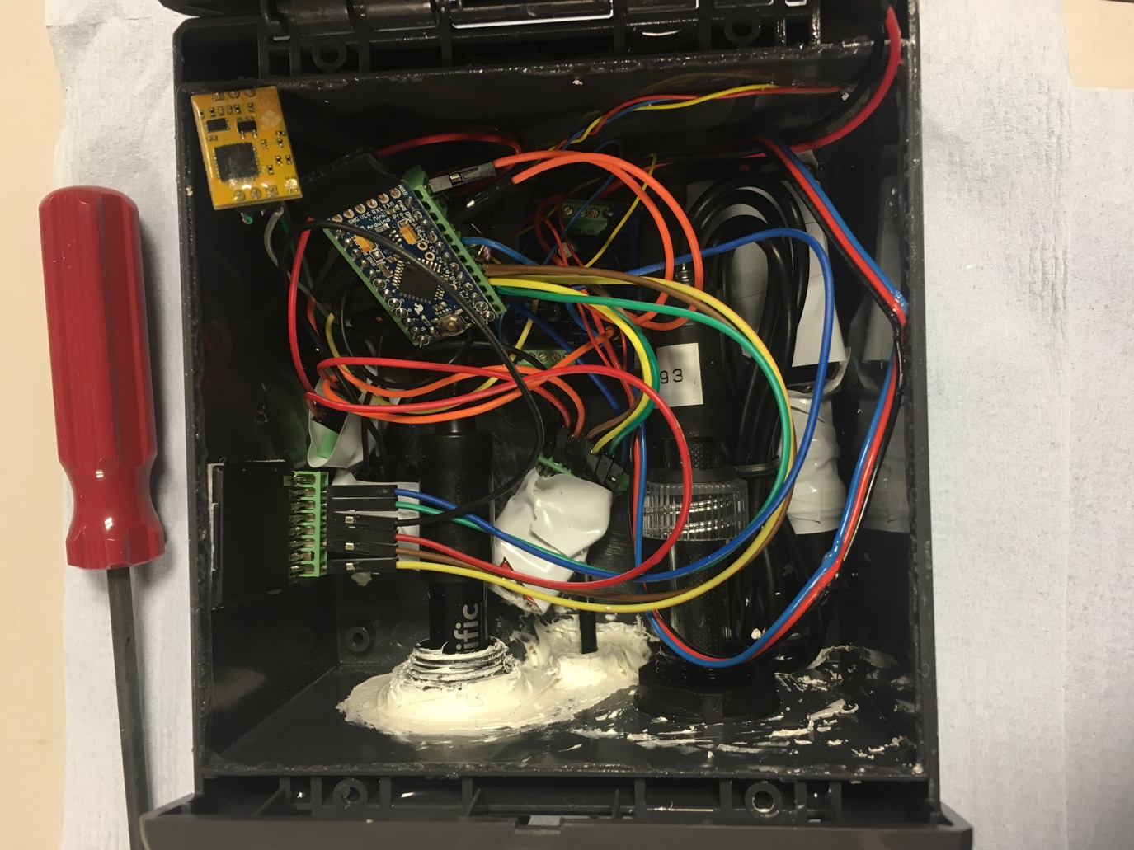

SD Card and SD Card Holder

Dissolved Oxygen Probe

Clock protected with tape to secure wiring.

Temperature Sensor

Dissolved Oxygen Shield (5V)

Arduino Pro Mini 3.3V

Breadboard containing voltage regulator and transistor

Wiring for Pressure Sensor (5V). Entrance to the bottom of the casing.

Conductivity Probe. *Note: in this image the probe is different and the handmade conductivity probe has been replaced with an Arduino conductivity probe.*

*Note: Batteries are not pictured, but are attached in a 6 slot battery pack and wired to GND and RAW.*